Experiment No .7

7.1 Aim: STEGANOGRAPHY: Using tools like Steghide or OpenStego.

Example Scenario:
You are working as a student intern in a digital forensics training lab. Your instructor has provided you with several confidential files containing sensitive information related to a simulated investigation. To securely transmit these files without alerting unauthorized parties, you are asked to hide the secret data inside innocent-looking image files using steganography tools—Steghide (command line) and OpenStego (GUI). Later, you must extract the hidden data to verify that the original files can be recovered correctly. This exercise will help you understand how steganography conceals data and how forensic tools can be used to reveal hidden information.
Task:
- Select a secret file (e.g., confidential.txt) and a cover image file (e.g., cover_image.jpg).
- Use Steghide to embed the secret file inside the cover image with a passphrase.
- Extract the hidden file from the stego image using Steghide and the passphrase.
- Use OpenStego to embed a secret file inside another cover image with password protection.
- Extract the hidden file from the OpenStego stego image using the password.
- Verify that the extracted files match the original secret files.
- Document the embedding and extraction process with screenshots.

7.2 Lab Outcome :
- To learn how to embed secret files into images using Steghide and OpenStego & gain practical knowledge of steganography as a forensic tool.
7.3Learning Objectives:
- To learn, embed and extract secret data using Steghide via command line.

- To learn, embed and extract secret data using OpenStego via GUI.

- To Understand the role of passphrases in securing hidden data.

7.4 Requirement:
Hardware:
- Desktop or laptop system (for investigation)
- USB flash drive (for testing)
Software Tools:
- Computer with Steghide installed (Linux, Windows, or macOS).
- OpenStego installed (Java Runtime Environment needed).
- Sample cover files (e.g., crime_scene.jpg, suspect_photo.png).
- Sample secret files (e.g., evidence.txt, confidential_report.txt).
- Terminal or command prompt access for Steghide.
- OpenStego GUI application.
- Internet connection
7.5 Related Theory :
Steganography conceals secret information inside ordinary files such as images or audio without revealing its existence. This differs from encryption, which scrambles data but does not hide its presence. Steghide and OpenStego are tools that embed secret files inside media files using encryption and compression, requiring a passphrase for secure hiding and extraction. In forensic investigations, steganography helps securely transmit evidence and uncover hidden data critical to cases.

How Steganography Works
In digital steganography, secret data (such as text, images, or audio) is embedded inside a cover medium, typically an image, audio, or video file. The cover medium acts as a carrier and appears unchanged or nearly identical to its original form to casual observers or analysis tools.
Common techniques include:
- Least Significant Bit (LSB) Insertion:
Modifying the least significant bits of pixels in an image or samples in an audio file to encode hidden information without significantly changing the original media.

- Masking and Filtering:
Embedding information by modifying significant areas of an image in a way that mimics watermarking.

- Transform Domain Techniques:
Hiding data by altering frequency components of audio or image files, making detection more difficult.

Applications of Steganography
- Covert Communication: Sending secret messages without arousing suspicion.

- Digital Watermarking: Embedding copyright or authentication information into digital content.

- Data Protection: Securing sensitive information in a way that hides its existence.

- Forensic Analysis: Detecting hidden files and data during investigations.

Tools for Steganography
Tools like Steghide and OpenStego allow users to embed secret files inside common media formats (e.g., JPEG, BMP, WAV) with optional encryption. These tools use steganographic algorithms combined with password-based encryption to protect hidden data from unauthorized access.

7.6 Output:
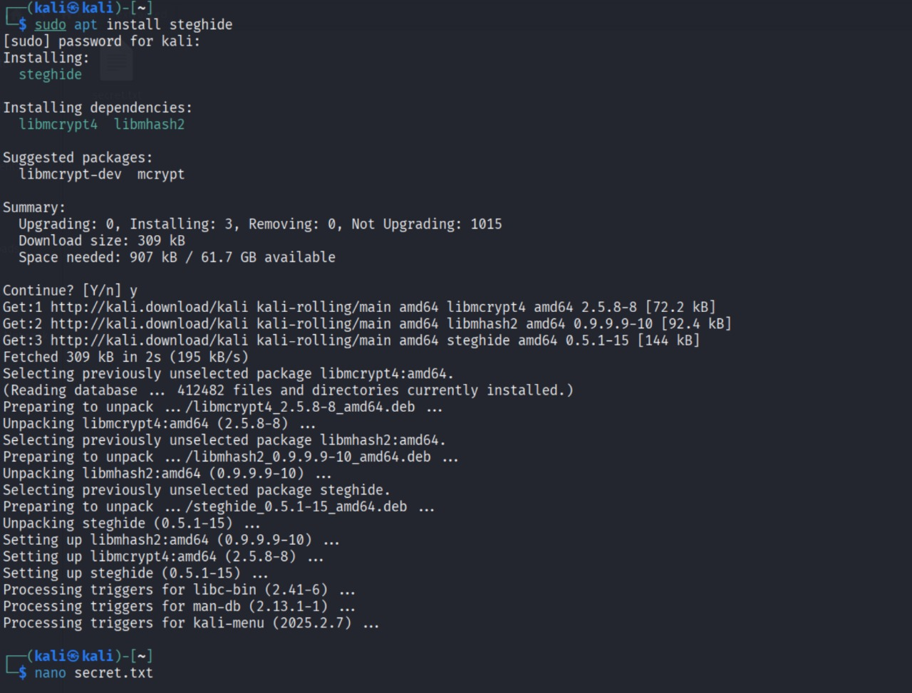

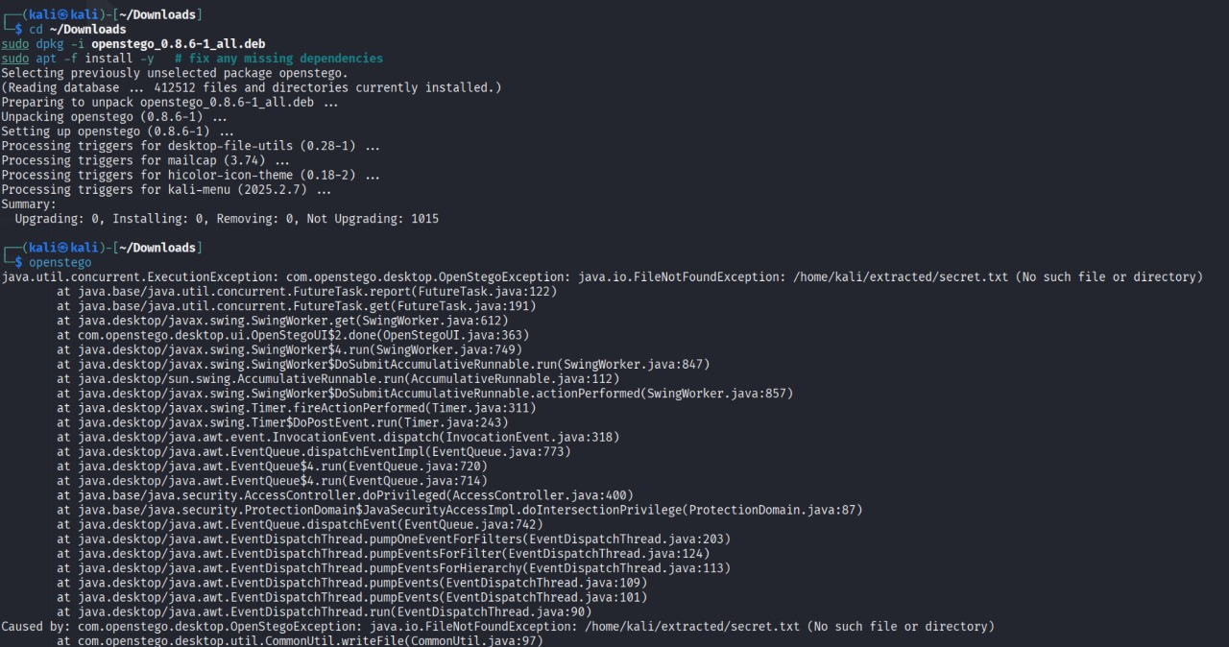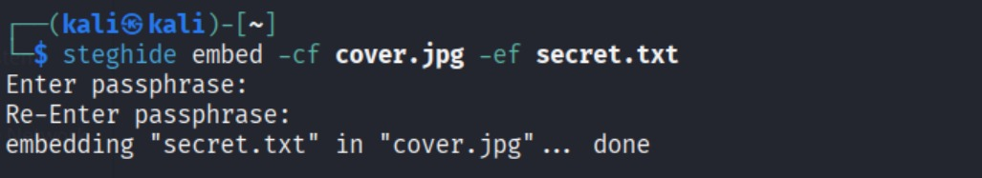
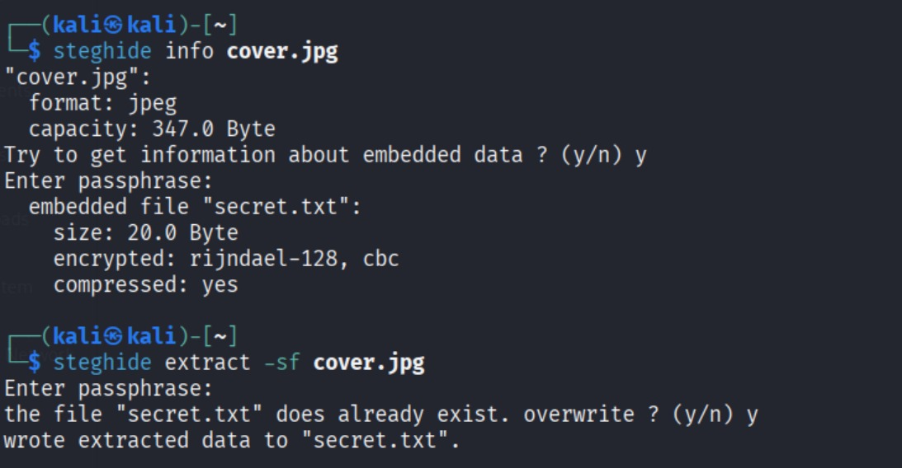
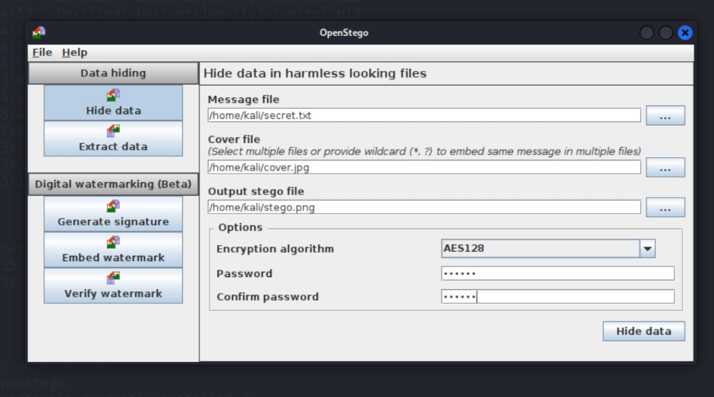
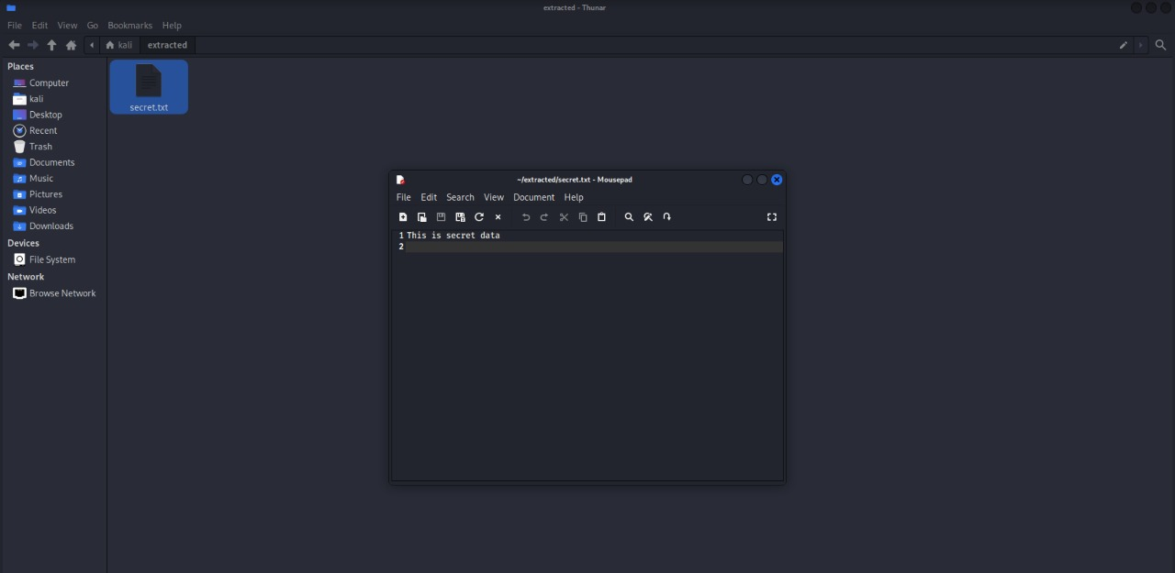

7.7 Conclusion:
In this experiment, we successfully learned and implemented the concept of steganography using Steghide (command line) and OpenStego (GUI). Secret files were securely embedded into cover images and later extracted using passphrases or passwords, verifying that the original data could be recovered without loss.
The practical exercise demonstrated how steganography differs from encryption by hiding the existence of data rather than just scrambling it. Through this, we understood the importance of passphrases in ensuring security and confidentiality of hidden information.
Overall, this experiment provided valuable insights into the working principles, applications, and tools of steganography, highlighting its role in covert communication, data protection, digital watermarking, and forensic investigations.
n this experiment, we successfully learned and implemented the concept of steganography using Steghide (command line) and OpenStego (GUI). Secret files were securely embedded into cover images and later extracted using passphrases or passwords, verifying that the original data could be recovered without loss.
The practical exercise demonstrated how steganography differs from encryption by hiding the existence of data rather than just scrambling it. Through this, we understood the importance of passphrases in ensuring security and confidentiality of hidden information.
Overall, this experiment provided valuable insights into the working principles, applications, and tools of steganography, highlighting its role in covert communication, data protection, digital watermarking, and forensic investigations.

